LAWS 200: BUSINESS ORGANISATION
ASSESSMENT TASK 2
PROBLEM QUESTION

INSTRUCTION:
This assessment task is problem based and provides an opportunity to assess learning outcomes 1-4. The rubric attached at the bottom, provides stipulated expectations and a guide on how the assessment will be marked.

Assessment Due Date: Friday 18 September 2017
Weight: 35%

QUESTION:
Julie, Trump, Malcom, Trudeau, Macron and Michelle are all shareholders in Amy’s Angel Pty Ltd (hereinafter referred to as Amy’s angel), an energy company duly registered by ASIC. Michelle who is the majority shareholder lives in London and is also a director of the Company. Julie, Trump, Trudeau and Malcom are also directors and live in New Zealand, USA, Canada and West Germany respectively. Macron who holds the least number of shares is the energy expert for the company. He is not a director but works in the company as a consultant. The managing director (Trump) and the other members of the board (Julie, Malcolm, Trudeau and Michelle) hold him in high regard and do not take any decision without first consulting him.
Macron’s wife (Rose) recently became a director in Sharon Angels Pty ltd (hereinafter referred to as Sharon Angels) and it is a competitor energy company to Amy’s Angel. Macron is aware that Amy’s Angel has placed a $1m bid for a contract and has informed his wife (Rose) about this. Based on this information, Rose advised Sharon Angels to place a bid above $1m. Without this advice, Sharon Angels would not have placed such a high bid. Sharon Angels won the bid and has offered Macron $10,000. Macron declined to take the money.
The board of directors of Amy’s Angel have become aware that Macron disclosed the bid amount to his wife who in turn disclosed it to Sharon Angels. As can be imagined, they are angry with Macron. Michelle, sends out an email detailing all the statutory requirements for a director’s meeting and notes that the meeting shall be held via skype. Macron who always attends all such meetings is invited as usual and replies that holding such a meeting via skype would contravene the provisions of the Corporations Act.
Macron aware of the issues to be discussed has sent separate emails to each of the directors that he would deal with each of them. At the director’s meeting held via skype, the directors passionately express their disappointments at Macron’s action (informing his wife about Amy’s Angel bidding price) and agree unanimously that such actions are a breach of director’s duties.
In retaliation, Macron threatened to report that (Julie, Malcolm and Trudeau) took a loan of $1m each from the company when they all knew that the company was unable to pay most of her creditors. Macron further noted that he had expressed his views during the meeting that it would not be in the best interest of the company for such monies to be loaned out at such a time and that he only signed the resolution approving the loan to make the directors happy and now they are all against him. Michelle responded that he should go ahead and report it, that they did nothing wrong as it was duly approved by the board of directors before the money was taken. Macron has reported the case to ASIC.
ASIC has decided to institute legal action and has approached you for the following:
- Identify the legal issues in the scenario that are in contravention of the Corporations Act.
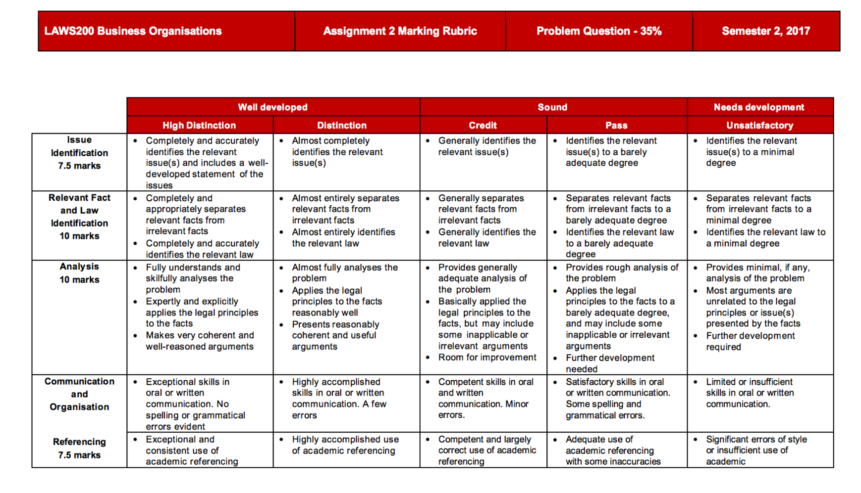
- Advise each party on their possible breaches of director’s duties and if any defences are available.

